—FOR IMMEDIATE RELEASE—

HUDSON VALLEY THEATRE INITIATIVE presents its first local production, #QueenE the Musical, at the Howland Cultural Center (477 Main St, Beacon NY 12508) at 3pm and 8pm on August 11th & 12th, after the company's wonderfully successful presentation of the children’s musical, The Mitten, back in March.

Rooted in the truth of a remarkable era in history, #QueenE brings to life the story of Queen Elizabeth I in a 90-minute musical experience with an incredible local cast. Mary Stuart, Mary Tudor, Phillip of Spain, and more are personified and modernized in this entirely original production that will leave you dancing, singing, and motivated to make the world a better place.

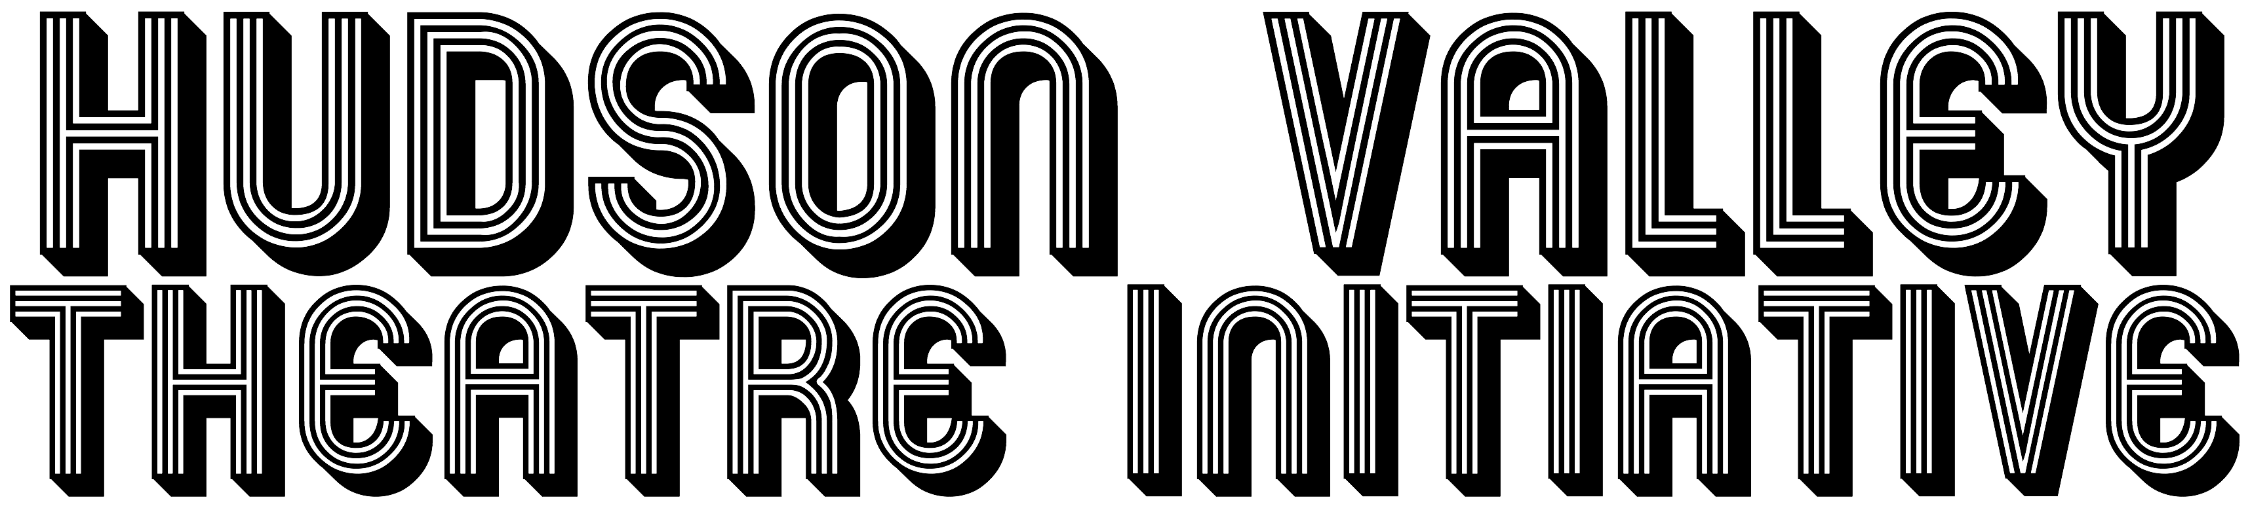
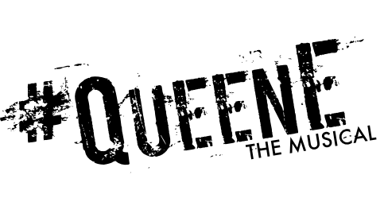
“We are thrilled to bring this production to life,” says Artistic Director, Todd Hulet. “#QueenE is a musical for a more mature audience with challenging historical themes and difficult emotional situations, but told in a way that you can still bring your kids along with you. This is adult theatre, sophisticated theatre, perfect for the whole family.”

Show Synopsis:
Queen Elizabeth I has many nicknames, and the truth behind any of them is none of your business. In a dramatic pop-concert setting, Elizabeth tells her story: a girl suddenly wielding immense and enviable power discovers her unwanted privilege comes with the constant torment of opposing extremists. But life has taught her never to shy from her own self-worth, and if she is valued as the sovereign of the British Empire, then she will rule. Her way.

All ages will be admitted, ages 10 & up encouraged. Presale Tickets $7.50 children, $10 adult, At-The-Door Tickets $10 children, $15 adults. Please visit HVTI.org for more information and to purchase tickets.

